Msales Deployer

**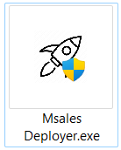****GUI tool for deploying the 'MSales' WAR files to different Tomcat instances—one for the backend (BE) and another for the frontend (FE). This GUI tool is named 'mSales Deployer'.**

**To configure the deployment using the 'mSales Deployer' tool, follow these steps:**

1. **A stack of books with a buckle

   Description automatically generatedEdit an “application.properties” file and place it in the same directory as the 'mSales Deployer.exe' tool.**
2. **In the application.properties file, specify the following parameters according to your setup:**

* **For the backend Tomcat instance:**
* **backend_tomcat_path: Provide the path to the backend Tomcat installation, e.g., 'C:\Program Files\Apache Software Foundation\Tomcat 9.0'.**
* **backend_services_name: Specify the name of the backend Tomcat service executable, e.g., 'Tomcat9.exe'.**
* **For the frontend Tomcat instance:**
* **frontend_tomcat_path: Provide the path to the frontend Tomcat installation, e.g., 'C:\Program Files\Apache Software Foundation\Tomcat9-msalesportal'.**
* **frontend_services_name: Specify the name of the frontend Tomcat service executable, e.g., 'Tomcat9-msalesportal.exe'.**
* **For the backup folder:**
* **backup_folder_path: Specify the path to the backup folder, e.g., 'F:\Mseles\msales-deployer'.**

1. **Once you've configured the “application.properties” file, ensure that the new WAR files you want to deploy are placed in the same directory as the 'mSales Deployer.exe' tool.**

**By following these steps and providing the necessary information in the “application.properties” file, you can initiate the deployment process using the 'mSales Deployer' tool for both the backend and frontend components."**

ـــــــــــــــــــــــــــــــــــــــــــــــــــــــــــــــــــــــــــــــــــــــــــــــــــــــــــــــــــــــــ

**The application includes the following components:**

1. **Buttons:**

* **"Deploy":** **Initiates the deployment process.**
* **"Backup & Deploy": Initiates the deployment process after creating a backup.**

1. **Checkboxes:**

* **"Integration Gateway": Check this if the customer uses the Integration Gateway component.**
* A screenshot of a computer

  Description automatically generated**"Customer App": Check this if the customer uses the Customer App component.**

**Here's what each button and checkbox does:**

* **Deploy Button:**

**When you click the 'Deploy' button, the application will execute the following steps:**

1. Depending on the selected checkboxes, deploy the Integration Gateway, Customer App, both, or none to both the backend (BE) and frontend (FE) components.
2. Stop the services for both the backend (BE) and frontend (FE) Tomcat instances.
3. Delete the existing WAR files for both the backend (BE) and frontend (FE) from their respective web application directories.
4. Copy the new WAR files to their respective directories.
5. Start the services for the backend (BE) instance.
6. Wait for the backend (BE) Tomcat instance to fully start.
7. 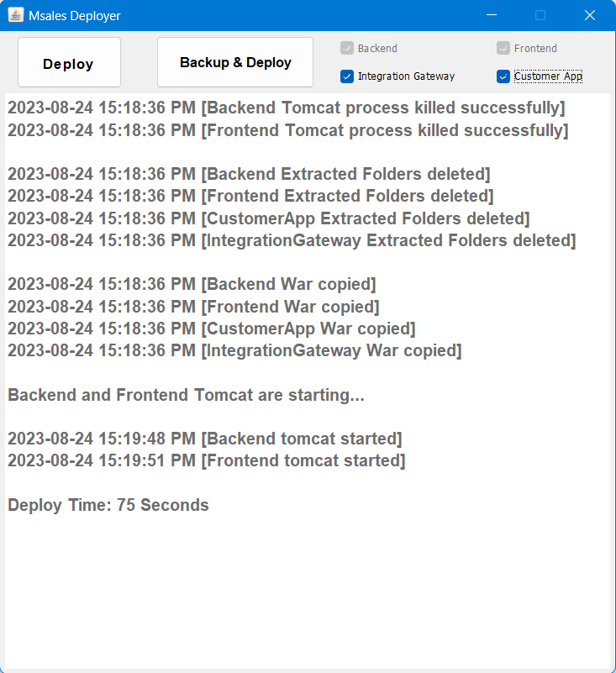Once the backend Tomcat is up, the application will proceed to deploy any additional required WAR files."

* **Backup & Deploy Button:**

**When you press the 'Backup & Deploy' button, the application will perform the following actions:**

1. Create a backup of the current WAR files and store them in the specified backup_folder_path.
2. Depending on the selected checkboxes, deploy the Integration Gateway, Customer App, or both.
3. Stop the services for both the backend (BE) and frontend (FE) Tomcat instances.
4. Delete the existing WAR files for both the backend (BE) and frontend (FE) from their respective web application directories.
5. Copy the new WAR files to their respective directories.
6. Start the services for both the backend (BE) and frontend (FE) Tomcat instances.
7. Wait for the backend (BE) Tomcat instance to fully start.
8. 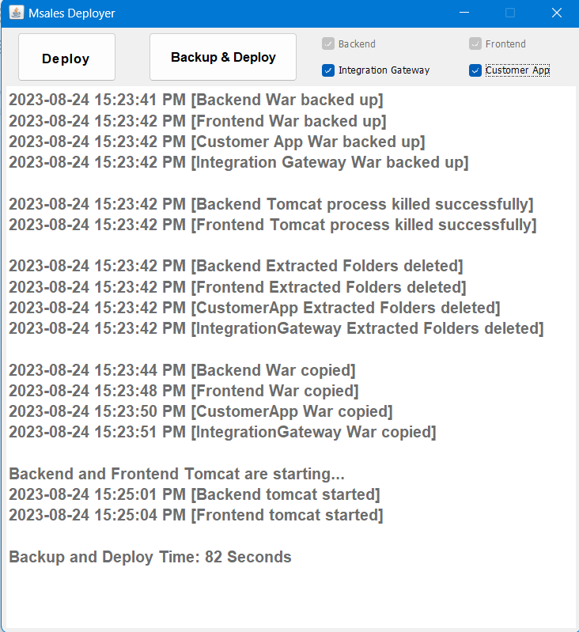Once the backend Tomcat is up, the application will proceed to deploy any additional required WAR files.